document type:- Proxy Statement 14 A

plugin_name:- OWNERSHIP_EXTRACTOR.OwnershipExtractorPlugin

**List of Source Files Involved:-**



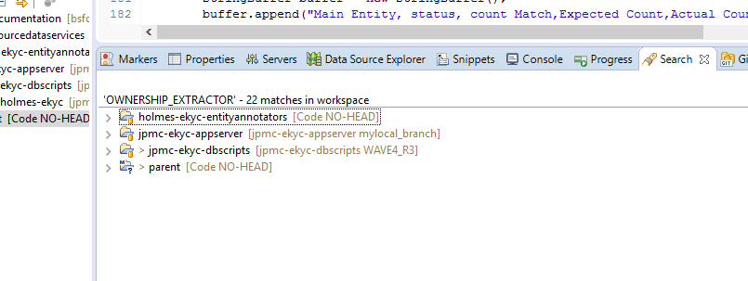

1. holmes-ekyc-entityannotators

OwnershipInfoExtractionController.java

This is the controller which having the blow methods 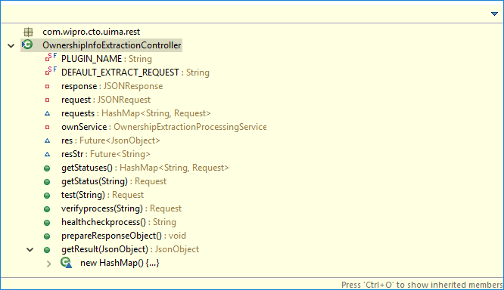

JSONResponse

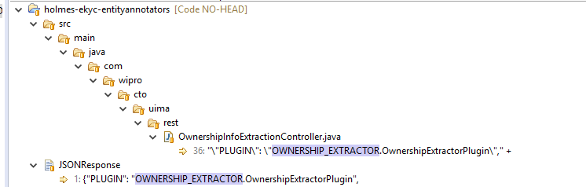

1. jpmc-ekyc-appserver

Ownership_Extraction_Plugin.java

OwnershipHtmlExtractor.java

OwnershipProxyHTMLExtractionTest.java

logback.xml

Constants.java

USPlugin.java

JSONRequest.java

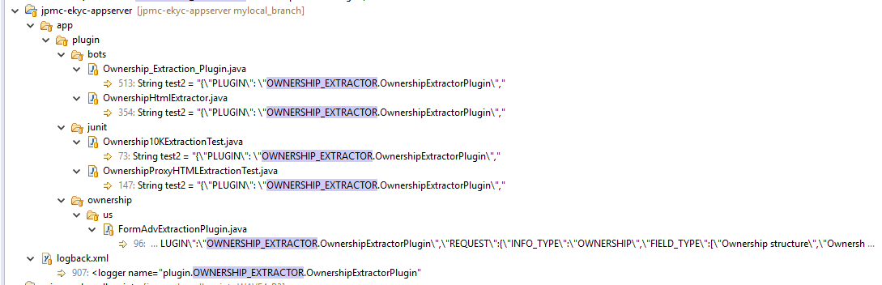

1. jpmc-ekyc-dbscripts

WAVE4_R3 - detailed_plugin_list_Table_Values_US.sql ----- 🡪 “Proxy Statement 14 A” doc

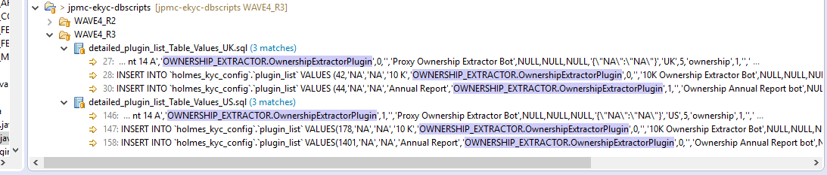

1. parent (cognitive_ekyc_features)

DocumentAnalysis - TestMain.java

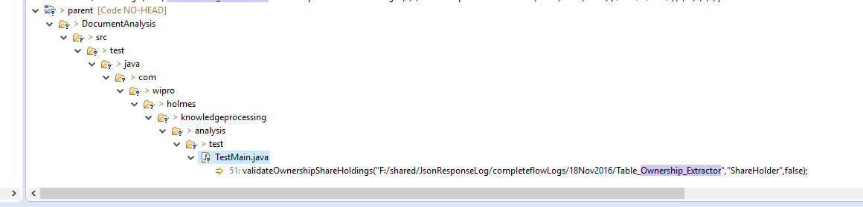

1. holmes-ekyc-scraperplugins

OwnershipExtractorPlugin.java

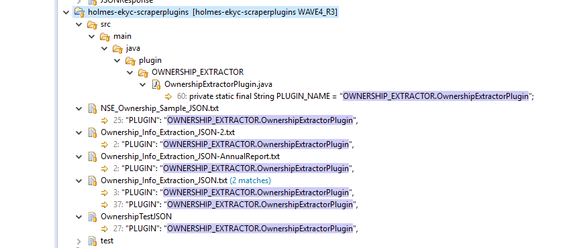

**FLOW of the DEF14A:-**

Below is the main class and it’s method from where the flow gets started……..

Ownership_Extraction_Plugin.java

public static void main(String args[]) throws Exception {

While run the application getting below database connection errors

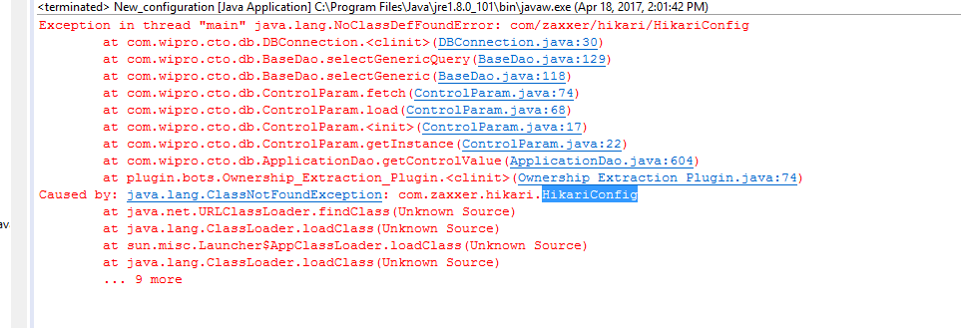

what this main method does are as below,

1. defines the value for sourceLink, docLink ,companyName
2. Create the request JSON Object by parsing the request parameter received,
3. Generate the response JSON Object by calling the method of getResult() of plugin Ownership_Extraction_Plugin.
4. What getResult method does,

Basically this method takes request as JSON object and return the response as JSON Object.

Step 1: This is actually creating three type of array from received JSON request Object to field_Name, fiel_Type, and Info_Type.

Step 2: And from these array it convert to arraylist of it’s respective types.

Step 3: Again check if Info_type is not ‘CONTROLLER’ Then continue the flow else not.

Step 4: Set the STATUS as ‘SUCCESS’ and set the value for company_name and download path,

Step 5: Create an array for the constants those are defined in Constant.java source file,

Step 6: If JSON request object has value for ‘ISTEST’ is ‘true’ then get the value from itself otherwise connect to AppicationDao through DBConstants.USER_DATA_SOURCE and get the value from Database and set the value for source_link, docu_link

Step 7: Selenium WebDriver is used here for The URL to load. And create a list of webElement table.

Step 8: Create a list of string for each webElement from the above created table.

Step 9: Start searching and extracting the value for attributes like *MINIMUM_PERCENT_OWNERSHIP* using the patters and Matcher.

Step 10 : Adding the parameter values for the each fields in JSON object as response like STATUS, SOURCE_TYPE, SOURCE_NAME, DOCUMENT_TYPE,PPOB, ORIGIN_TYPE, SOURCE_TYPE, COMPANY_FULL_NAME, EXTERNAL_IDENTIFIER_SOURCE, EXTERNAL_IDENTIFIER_VALUE

Step 10: At the last it finally created the JSON Object and returned as response.